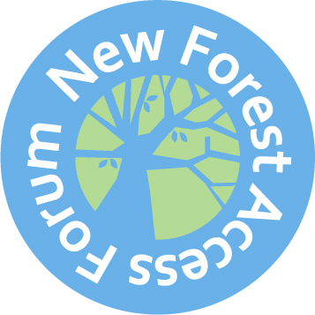

Recruitment Form
Personal Details
Name
Email or Postal Address
Phone Number
Areas of Interest
Please rank your top five interests in order. Mark “1” against the interest you could best represent, “2” for the next etc.
Walking |  |  | Tourism
Dog Walking |  |  | Local Business
Cycling |  |  | Under-represented groups
Equestrian (riding and/or driving) |  |  | Wildlife & Conservation
Commoning |  |  | Heath & Wellbeing
Accessibility (disabled access) |  |  | Youth/Education
Access to Water |  |  | Farming
Estate Management |  |  | Landowning
Volunteering |  |  | Other
Top Three Areas of Interest
Ranked interest #1: please give a brief description of your activity within this interest.
Ranked interest #2: please give a brief description of your activity within this interest.
Ranked Interest #3: please give a brief description of your activity within this interest.
Qualifications & Experience
Please list any relevant qualifications.
Please list any membership, previous or current, of relevant organisations (voluntary or paid) and your role within that organisation.
What experience do you have of engaging with others in constructive debate and working to achieve consensus?
What is the extent of your understanding of Rights of Way and Countryside legislation?
Please describe any other relevant skills and experience you would bring to the forum.
Communication Skills
How would you seek views on items coming up for discussion, and from whom?
Which groups or other organisations do you feel you have a close link with and could gain feedback and comments from?
How would you explain and publicise the work of the forum?
What do you see as the most important issues for the New Forest Access Forum to tackle?
Other details
Are you, or do you have any current or past connection with, a member of the New Forest National Park Authority or Hampshire County Council, including immediate members of your family? If yes, please give details.
Are you a member of a county, district or borough council? If yes, please give details.
Sign and date statement
I am applying to be a member of the New Forest Access Forum and certify that the information given on this form is correct, that I have read the Member Info Pack and, if appointed, agree to undertake the duties therein described.
Signed and Dated;

